**QUESTION 1**

**QUESTION 2**

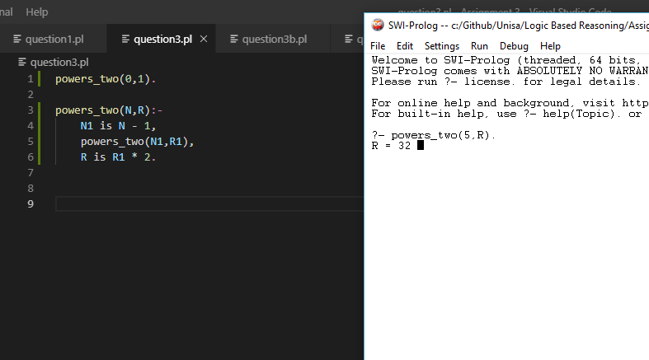

**QUESTION 3**

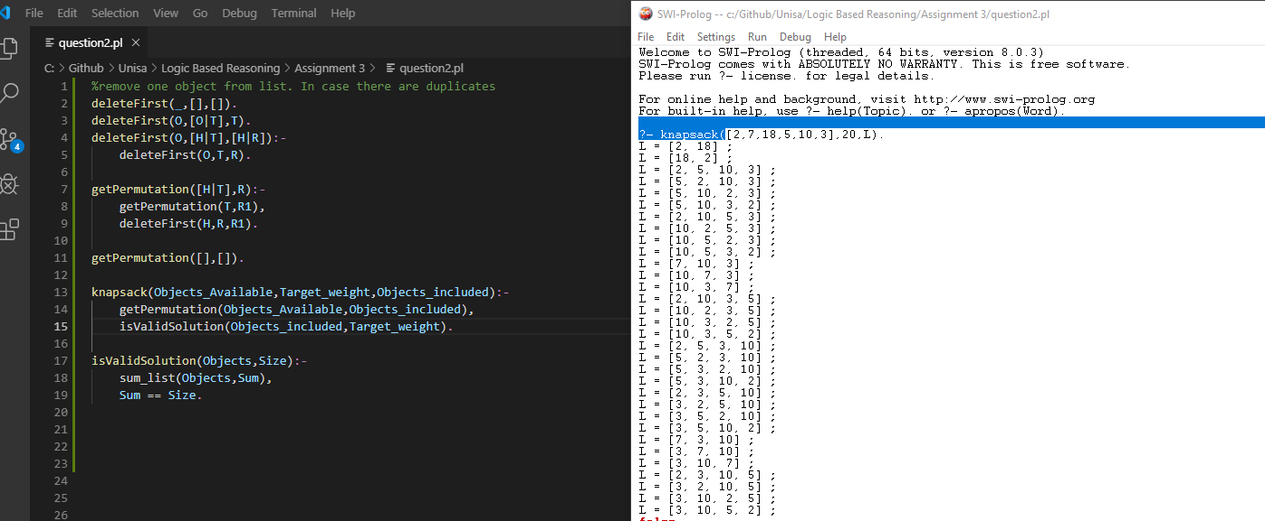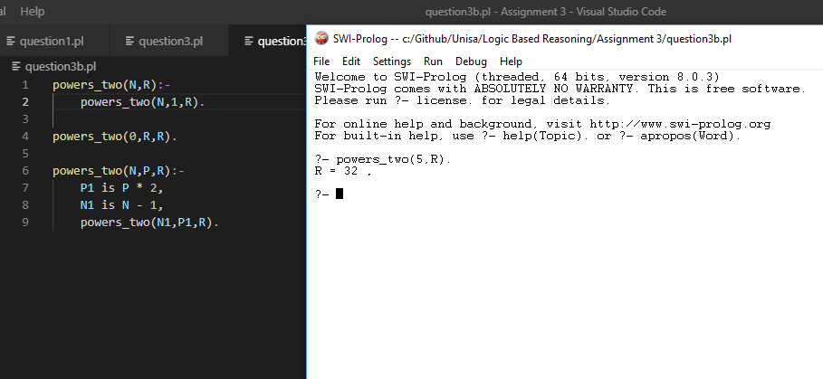

**QUESTION 4**

**QUESTION 5**

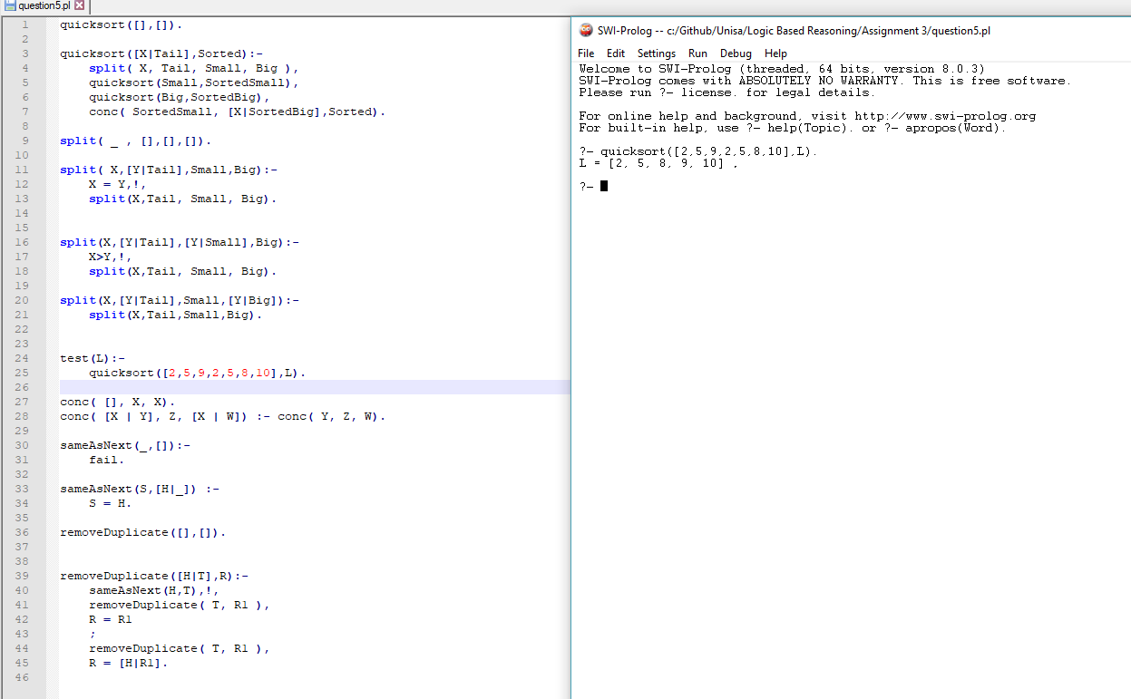

**QUESTION 6**

Starting off we have process 1 (P1) going to b and P2 going to c. The f value of P1 at b is f(b) = 3 + 3 = 6. And the f value of P2 at c is f(c)=3+4 = 7. Since the f value of P1 is lower, P1 will continue to d and a new process named P3 will go from b to e.

Now for P1,f(d) = 6 + 3 = 9. For P3 f(e) = 6 + 4 = 10 and for P2 f© = 7. Now P2 will continue to e,

For P2 at e f(e) = 7+4 = 11. Tis is now larger than the f value for P1 at d which is 9 and P3 at e which is 10. Thus P1 continues and reaches the end goal at x.

